31.62: a) 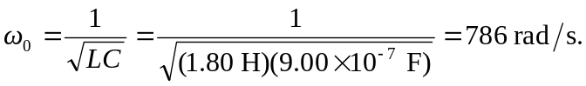
b) 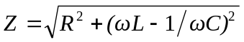
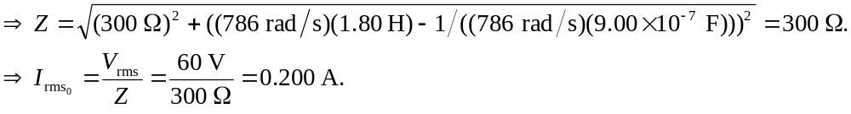
c) We want
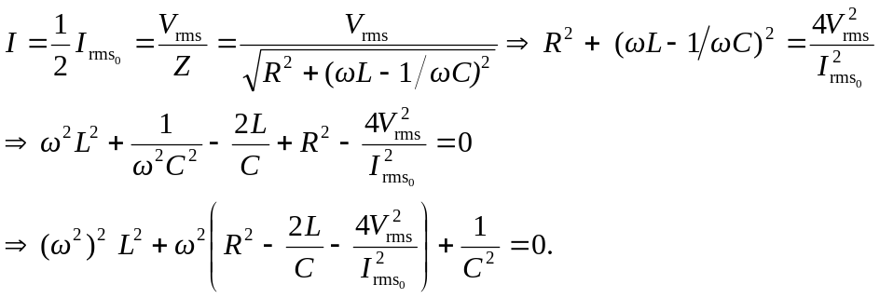
Substituting in the values for this problem, the equation becomes: 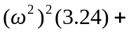
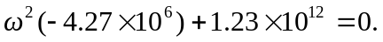
Solving this quadratic equation in 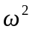we find 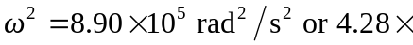
d) (i)
Width gets smaller as R gets smaller; 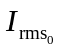gets larger as R gets smaller.

